IP Horizon 5.0 Conference: Book your place until 12 September

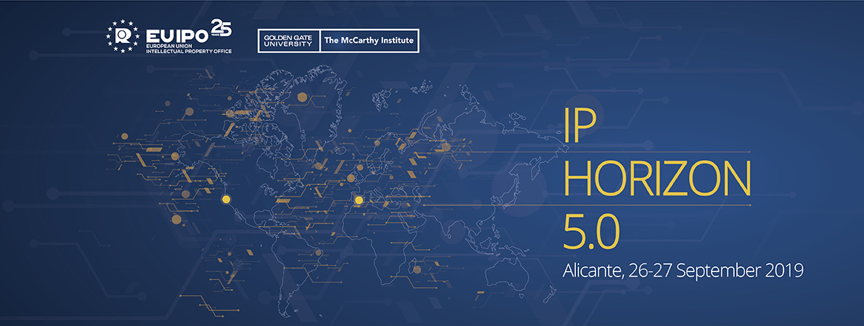

On 26 and 27 September 2019, the EUIPO will host the ‘[IP Horizon 5.0 Conference](https://euipo.europa.eu/ohimportal/en/ip-horizon-5.0-conference): Mapping opportunities and challenges in a globalised economy’ at its premises in Alicante, Spain.

In conjunction with the prestigious [McCarthy Institute](https://www.mccarthyinstitute.com/), the conference will look at the **future of intellectual property and the opportunities and challenges that lie ahead for IP in the age of digital transformation.**

**Join the 5.0 revolution:**

The so-called ‘Industrial Revolution 5.0’ – the future changes that society will undergo – has been associated with closer cooperation between innovation and humankind. In general terms, the first industrial revolution featured mechanisation and steam engines, the second one focused on mass production and electricity, the third one on electronics and IT systems, and the fourth industrial revolution is linked to the digitisation of society and interconnectivity. But how far is the 5.0 horizon and what will be its impact in the field of IP?

The IP Horizon 5.0 Conference will bring together representatives from some of the world’s most innovative IP offices, businesses and academic institutions to **explore the impact of new developments and emerging technologies applied to IP**, including potential policy initiatives and efforts to harmonise IP in a globalised economy.

**The world’s IP leaders:**

Over the course of two days, Alicante will become a beacon of IP expertise. The [conference programme](https://euipo.europa.eu/tunnel-web/secure/webdav/guest/document_library/contentPdfs/IP_Horizon_5_Conference/IP_Horizon_Conference_Preliminary-Draft-Programme_en.pdf) includes **top representatives from leading global companies** including Microsoft, Samsung, Sony, Alibaba and Philips will give the industry view and **key intellectual property figures** from the [WIPO](https://www.wipo.int/portal/en/index.html), [EPO](https://www.epo.org/index.html), [TM5 partner offices](http://tmfive.org/about/) (United States, Japan, Korea and China), and the EU institutions. Enforcement authorities and academic institutions will also take part in the conference.

The programme is designed to encourage active discussion among participants, with various panel sessions covering different aspects of IP, from examination trends to future IP jobs, IP protection and cooperation initiatives.

For more details and to register, visit the [conference page](https://euipo.europa.eu/ohimportal/en/ip-horizon-5.0-conference). Please note that there are limited places available and **registration is open until 12 September**.